Assignment 3: Threshold-Based Alerting on Incremental Ingestion + Schema Evolution Handling
Problem Statement:
Batch pipelines frequently encounter two critical challenges: silent data surges and evolving schema changes. Without automated monitoring, a sudden spike in ingested rows can indicate an upstream bug or duplication. Simultaneously, schema drift from source systems like MySQL or APIs can silently break pipelines or cause data loss. This assignment addresses both challenges by integrating threshold-based anomaly alerts and implementing schema evolution handling mechanisms to ensure resilient, self-healing data pipelines.
Objective:
Enhance the batch ingestion pipeline to:
- Monitor and alert whenever the incremental data volume for a run exceeds 10% above the 5-day running average.
- Detect and handle schema changes (schema drift) in source systems (MySQL/API) to ensure resilient and adaptable ingestion.

Cloud Services to be Known:
AWS: EventBridge Scheduler, Lambda, CloudWatch Metrics & Alarms, Secrets Manager, SNS

Assignment Scope
- Daily Ingestion with Control Table Update
  - Ingest data from MySQL and/or API sources.
  - For each run, log metadata:
    - run_date
    - rows_loaded
    - Update the control table with ingestion status and row counts.
- Compute 5-Day Rolling Average
  - Schedule a daily SQL query to:
    - Calculate the average number of rows loaded over the past 5 days
    - Compare with the current day’s load
    - Store results in a monitoring table
- Define Alert Condition
  - If current_count > avg_last_5 * 1.10, trigger:
  - An insert into an alerts table or
  - A notification through an alerting mechanism
- Alerting via Monitoring Tools (Optional)
  - AWS: Push metric to CloudWatch, trigger Alarm
- Notification Delivery
  - Deliver alert via any of:
    - Email
    - Slack (Webhook)
    - AWS: SNS
- Schema Evolution Handling (New Scope)
  - Detect and handle changes in source schema such as:
    - New columns added
    - Existing columns removed or renamed
  - Implement a resilient ingestion script that:
    - Dynamically reads column structure at runtime
    - Applies transformation logic to align with target schema
    - Logs schema changes to a schema history table with versioning

Architecture Overview

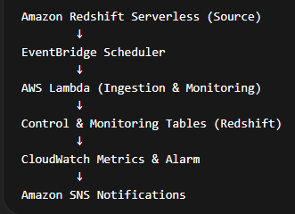

Project Objectives
This solution enhances a batch ingestion pipeline to:
- Monitor incremental data volume daily
- Detect ingestion spikes exceeding 10% of 5-day average
- Trigger automated alerts when anomalies occur
- Detect schema changes in source tables

1. Problem Statement
Batch ingestion pipelines often face two major issues:
- Silent Data Spikes
Sudden increases in ingested data volume may indicate duplication or upstream failures.
- Schema Drift
Source systems (MySQL/API) may change schema over time by adding, removing, or renaming columns.
If not detected early, these can break pipelines or corrupt data.

2. Objective
Build an automated ingestion monitoring system that:
- Detects data spikes exceeding 10% of the 5-day rolling average
- Detects schema changes in source tables
- Logs ingestion metrics
- Sends alerts through monitoring tools

PHASE 1 — Source Data Setup
Create source table and sample data to simulate incremental ingestion.

Service Used- Amazon Redshift Serverless

Implementation

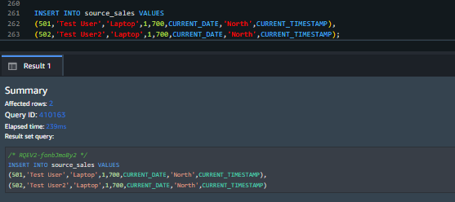
Outcome
Source table populated for ingestion monitoring.

PHASE 2 — Monitoring & Control Tables Setup

Objective - Create tables to store ingestion metrics, alerts, and schema history.

Service Used - Amazon Redshift Serverless

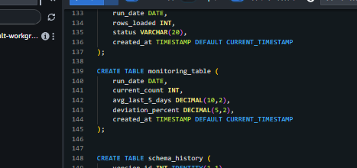

Outcome
Monitoring infrastructure created.

PHASE 3 — Secure Access Configuration Objective
Securely allow Lambda to connect to Redshift.

Store database credentials in Secrets Manager
Secret name:
redshift-credentials

Create IAM Role for Lambda
Role Name: LambdaIngestionRole
Policy | Purpose
AWSLambdaBasicExecutionRole | Lambda logging
SecretsManagerReadWrite | Retrieve DB credentials
CloudWatchLogsFullAccess | Write logs
AmazonSNSFullAccess | Send notifications
Custom policy:
{
"Effect":"Allow",
"Action":"cloudwatch:PutMetricData",
"Resource":"*"
}

PHASE 4 — Daily Incremental Ingestion

Objective
Fetch daily records and update ingestion metrics.

Services Used
- AWS Lambda
- Redshift Serverless

Process
Lambda performs:
- Retrieves credentials securely
- Connects to Redshift
- Fetches current day’s records
- Counts rows loaded
- Inserts ingestion metadata into control table

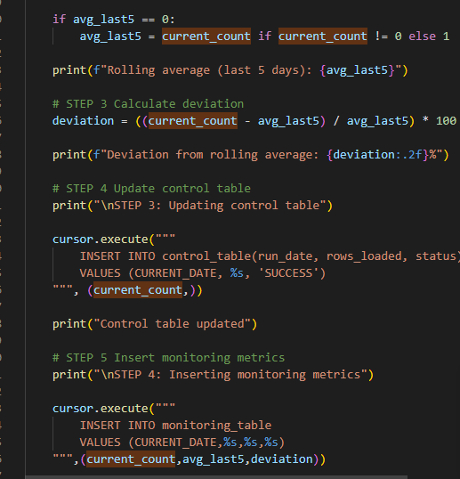

Example Query
SELECT COUNT(*)
FROM source_sales
WHERE sale_date = CURRENT_DATE;

Outcome
Control table updated with daily ingestion metrics.

PHASE 5 — Rolling Average Monitoring

Process
- Calculate 5-day rolling average:
SELECT AVG(rows_loaded)
FROM control_table
WHERE run_date >= CURRENT_DATE - INTERVAL '5 day';
- Compute deviation percentage
- Store results in monitoring_table
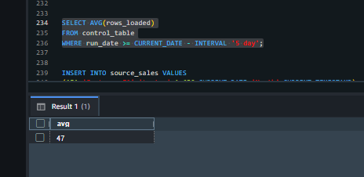

Outcome
Ingestion trends tracked for anomaly detection.

PHASE 6 — Threshold-Based Spike Detection

Alert Condition
current_count > avg_last_5_days × 1.10

Process
If condition is met:
- Insert alert record into alerts_table
- Trigger monitoring alert
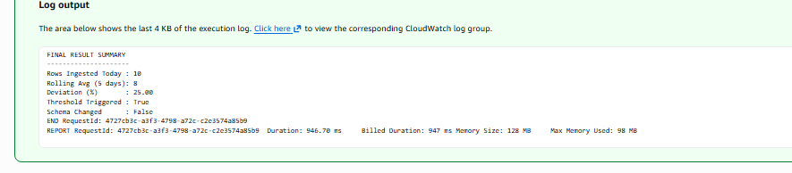
Spike detection mechanism implemented.

PHASE 7 — CloudWatch Monitoring & Alarm

Objective
Automate anomaly monitoring.

Services Used
- CloudWatch Metrics
- CloudWatch Alarms

Process
Lambda publishes custom metric:
IngestionSpike = 1
CloudWatch Alarm triggers when:
IngestionSpike > 1
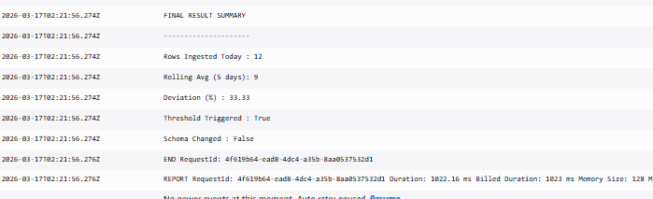

Automated monitoring of ingestion anomalies.

PHASE 8 — SNS Alert Notification

Objective
Notify stakeholders when anomalies occur.

Services Used - Amazon SNS

Process
- Create SNS topic
- Subscribe email recipients
- Attach CloudWatch alarm to SNS topic

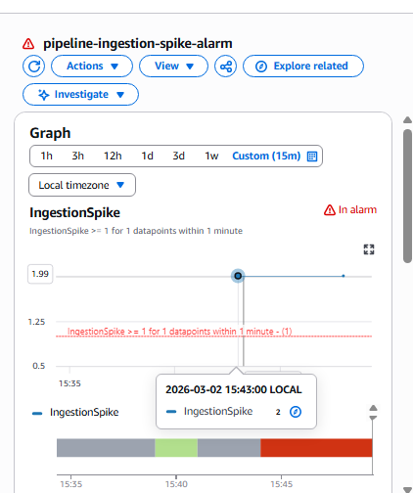

Outcome
Real-time email notifications delivered.

PHASE 9 — Schema Evolution Detection

Objective
Detect schema drift in source table.

Services Used
- AWS Lambda
- Redshift Serverless
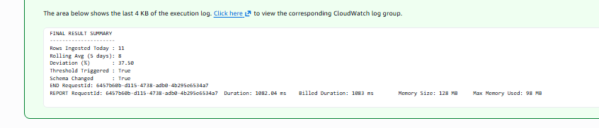

PHASE -10 Event Bridge Schedule
Trigger Lambda automatically.
Configuration:
Schedule Type: Recurring
Expression: rate(1 day)
Target: Lambda function
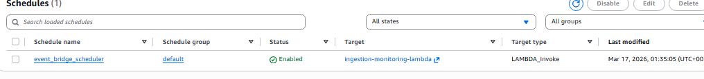
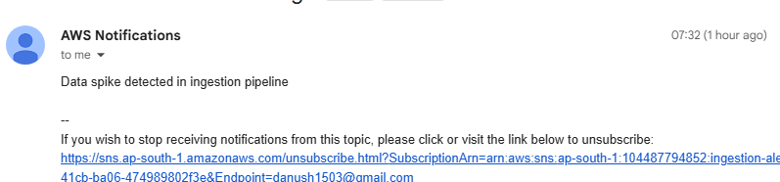
To Run on a scheduled basis - 1 day
Target – ingestion-monitoring -lambda

End-to-End Execution Flow
- EventBridge triggers Lambda daily
- Lambda ingests incremental data
- Control table updated
- Rolling average calculated
- Spike detection logic executed
- CloudWatch metric published
- Alarm triggers if threshold exceeded
- SNS notification sent

Project Outcome
This AWS-based solution provides a resilient ingestion monitoring pipeline capable of detecting abnormal data surges and automatically adapting to schema changes, ensuring reliable and self-healing data operations.

Source Data Setup

Create Source Table
CREATE TABLE source_sales (
sale_id INT,
product_name VARCHAR(100),
quantity INT,
price DECIMAL(10,2),
sale_date DATE
);

Insert Sample Data
INSERT INTO source_sales VALUES
(1,'Laptop',2,800.00,'2024-01-01'),
(2,'Mouse',5,20.00,'2024-01-01'),
(3,'Keyboard',3,50.00,'2024-01-02'),
(4,'Monitor',1,300.00,'2024-01-02');
Outcome:
Source table populated with initial data.

Monitoring Tables Setup
Create monitoring infrastructure.
CREATE TABLE control_table (
run_date DATE,
rows_loaded INT,
status VARCHAR(20),
created_at TIMESTAMP DEFAULT CURRENT_TIMESTAMP
);
CREATE TABLE monitoring_table (
run_date DATE,
current_count INT,
avg_last_5_days FLOAT,
deviation_percent FLOAT
);
CREATE TABLE alerts_table (
alert_id INT IDENTITY(1,1),
run_date DATE,
message VARCHAR(500),
created_at TIMESTAMP DEFAULT CURRENT_TIMESTAMP
);
CREATE TABLE schema_history (
version_id INT IDENTITY(1,1),
table_name VARCHAR(100),
schema_definition VARCHAR(1000),
change_detected_at TIMESTAMP
);
Outcome:
Monitoring infrastructure ready.

Lambda Code Logic
Steps executed by Lambda:
1️ Retrieve credentials from Secrets Manager
2️ Connect to Redshift
3️ Count today's rows
SELECT COUNT(*)
FROM source_sales
WHERE sale_date = CURRENT_DATE;
4️ Calculate 5-day rolling average
SELECT AVG(rows_loaded)
FROM control_table
WHERE run_date >= CURRENT_DATE - INTERVAL '5 day';
5️ Compute deviation
deviation = (current_count - avg_last5) / avg_last5
6️ Insert monitoring metrics
7️ Detect threshold spike
Condition:
current_count > avg_last5 * 1.10
8️ Detect schema evolution
SELECT column_name
FROM information_schema.columns
WHERE table_name='source_sales'
9️ Compare with last stored schema.

Threshold Testing
Insert spike data.
INSERT INTO source_sales VALUES
(1001,'Laptop',1,900,CURRENT_DATE),
(1002,'Mouse',2,40,CURRENT_DATE),
(1003,'Keyboard',1,80,CURRENT_DATE),
(1004,'Monitor',1,300,CURRENT_DATE),
(1005,'Tablet',2,400,CURRENT_DATE),
(1006,'Phone',3,700,CURRENT_DATE),
(1007,'Speaker',1,120,CURRENT_DATE),
(1008,'Camera',1,500,CURRENT_DATE);

Expected result:
Threshold Triggered : True
Verify:
SELECT * FROM alerts_table;

Schema Evolution Testing
Modify source schema.
Example:
ALTER TABLE source_sales
ADD COLUMN region VARCHAR(50);
Insert new record.
INSERT INTO source_sales
VALUES (2001,'Laptop',1,900,CURRENT_DATE,'South');
Run Lambda again.
Expected result:
Schema Changed : True
Verify: SELECT * FROM schema_history;

